

Functional Requirements and Use Cases

eShop Interim

Vodafone Turkey

|  |  |
| --- | --- |
| Version: | 0.3 |
| Issued: | September 16th 2015 |
| Author: | Alin Radu |

## Document Approvers

|  |  |  |  |
| --- | --- | --- | --- |
| Name | Role | Company | Approval Date |
| Tom Freemantle | Project Manager | PJ Media | September 16th 2015 |
| Ozkan Mustafa | Head of Product Development | PJ Media | September 16th 2015 |
| Valentin Stefan | Account Manager | PJ Media | September 16th 2015 |
| Ürün Taylak | Project Manager | Vodafone Turkey |  |
| Utku Bektas | e-Commerce  Product Executive | Vodafone Turkey |  |

## Document Info

|  |  |  |  |
| --- | --- | --- | --- |
| Version | Comments | Author | Date |
| 0.1 | Document created: first draft version | Alin Radu | September 15th 2015 |
| 0.2 | Document revised and added Use Cases | Alin Radu  Ozkan Mustafa | September 16th 2015 |
| 0.3 | Review and addition to the RAID Section | Alin Radu | September 16th 2015 |
|  |  |  |  |

## Table of Contents

Document Approvers 1

Document Info 1

Table of Contents 2

1. Introduction 3

1.1. Business Objectives 3

1.2. Key Project Deliverables 3

1.3. Document Scope 3

1.4. Abbreviations and Terms 4

2. Current Situation 5

2.1. High Level Requirements 6

2.2. High Level Solution 7

3. Detailed Analysis 8

3.1. Detailed Requirements 8

3.2. Out of Scope Requirements 10

3.3. Removed Requirements 11

4. R.A.I.D. 13

4.1. Risks 13

4.2. Assumptions 13

4.3. Issues 13

4.4. Dependencies 13

5. Use Cases 15

## Introduction

Vodafone Turkey is requesting PJ Media to implement the approved design Cep Merkezi website to be responsive and. Vodafone Turkey also requires the capability to choose devices for sale in the CMS directly.

## 1.1. Business Objectives

The Interim project is the first step towards full eShop experience that will allow existing VFT customers to buy online selected devices via the Cep Merkezi site and My Account. Future phases will allow new customers to buy online also.

## 1.2. Key Project Deliverables

## 1.3. Document Scope

This is an analysis document describing the detailed requirements for the Vodafone Turkey Interim work for the eShop as per the agreed commercial proposal and also providing use cases.

## 1.4. Abbreviations and Terms

|  |  |
| --- | --- |
| Item | Description |
| VFT | Vodafone Turkey |
| BSS | Business Support System |
| Online Cep Merkezi | Online Mobile Centre |
| HLP | High Level Plan |
| HLSO | High Level Solution Outline |
| CRM | Customer Relationship Management |
| RAID | Risks Assumptions Issues Dependencies |
| OMS | Order Management System |
| CMS | Content Management System |
| OOTB | Out Of The Box |

## 2. Current Situation

Current functionality of Cep Merkezi website permits users to browse through devices and plans, but there is no possibility for users to buy online. Once the products are added to the Basket, the user has the possibility to print order, email order or view physical stores map.

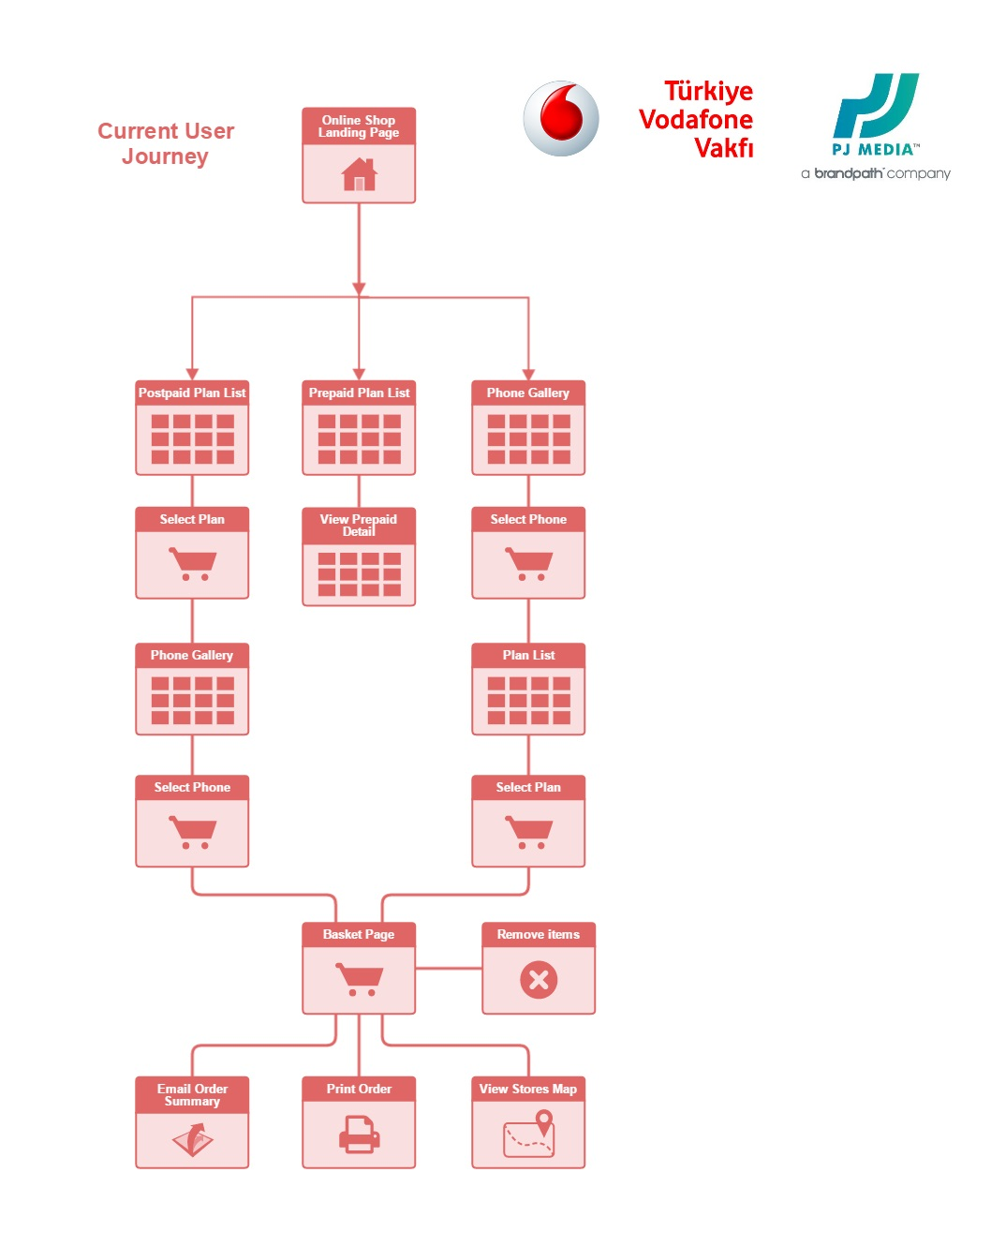Below is the current User Journey:

## 2.1. High Level Requirements

|  |  |
| --- | --- |
| ID | **Device contracting to existing Vodafone customers.** |
| 2.1 | VFT require selling devices that VFT define. Thus, for each device buy button visibility should be managed via CMS. |
| 2.2 | If the customer clicks buy button the Vodafone My Account Login page should be presented, passing the Device SKU code Tariff SKU and ICMP. |
| 2.3 | There should be a selectable horizontal filter to allow customer to find devices in eShop according to multiple variations. |
| 2.4 | There should be device colour selection capability. |
| 2.5 | The user journey is being modified through this process, for an existing Vodafone Turkey customer browsing the Cep Merkezi pages. |
| 2.6 | VFT will select which phones from Cep Merkezi they wish to sell, managing this via the CMS. |
| 2.7 | There will be an additional check box added to the filter on the product listing page to allow customers to filter on phones for sale. |
| 2.8 | Managing Colour and Memory Size Variation in Products |
| 2.9 | On the Phone Details page a colour selector and memory selector will be added so that the users can change to a version of the same device in a different colour or memory size. Where no colour or size has been selected a default one set in the CMS will be used |

## 2.2. High Level Solution

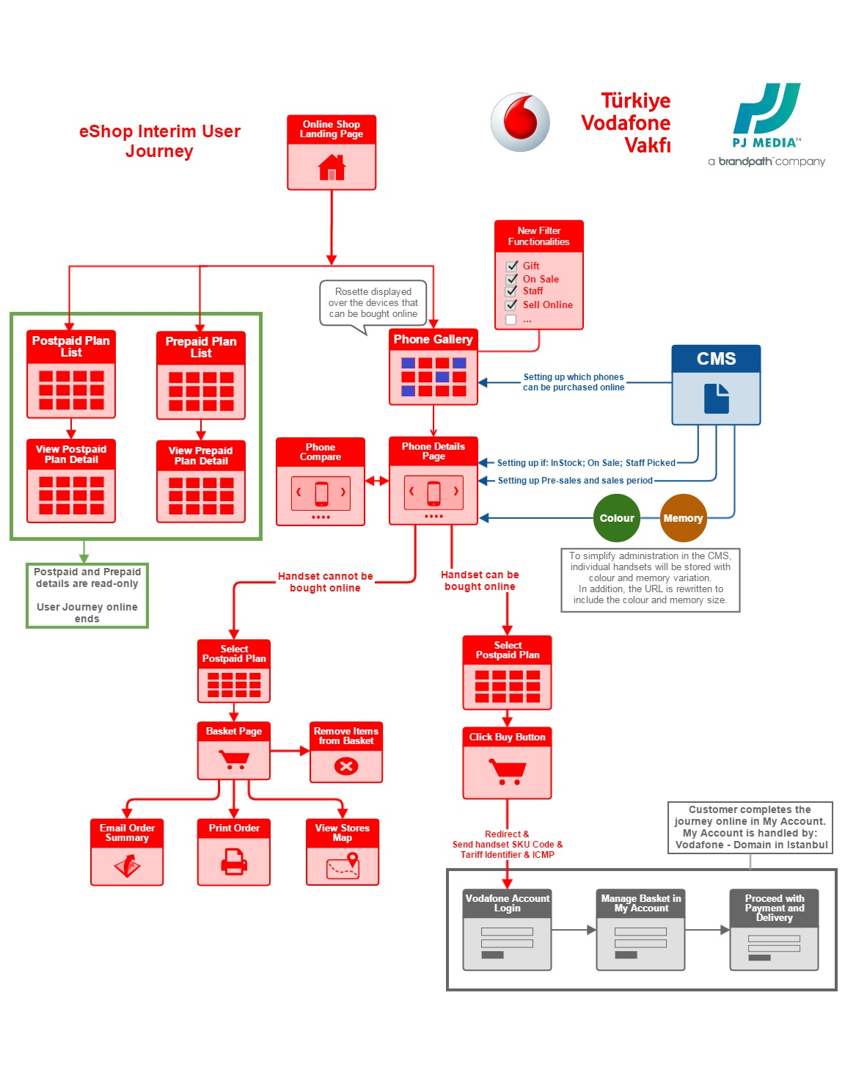 The new user journey is being modified through the Interim project for a Vodafone Turkey customer browsing the Cep Merkezi pages. For defined devices, users will be able to select post-paid plan and buy online. The Buy button will redirect the user to the My Account section, hosted by Vodafone, where they complete the order.

## 3. Detailed Analysis

## 3.1. Detailed Requirements

|  |  |  |
| --- | --- | --- |
| 1 | Request | Vodafone require the ability to select what devices on the eShop can be bought online and which cannot, via the CMS. |
| Solution | This will be managed as described through the CMS. |
| 2 | Request | There should be a visible rosette displayed over those devices so that they are easy for the customer to identify what devices can be bought online. |
| Solution | The on-off rosette will be applied to the devices that can be bought online. Embed |
| 3 | Request | There should be a visible rosette displayed over those devices that have a free accessory bundled with them. The image will be the same irrespective of how may accessories there are or their type. This should be managed from the CMS. Where the device also carries the ‘buy online’ rosette that should be displayed instead. No more than one rosette will be displayed on any device. In addition the product details page should have space for a banner to describe the gift or accessory included. |
| Solution | The on-off rosette for accessories will be applied as described above and the page details template will be amended to include the banner. |
| 4 | Request | If the customer clicks ‘buy’ button the Vodafone My Account Login page should be passed any ICMP code in addition to the Device SKU and Tariff SKU. |
| Solution | When a user comes on to the Cep Merkezi site any ICMP code that they are passed with will be added to the browser session and then added to the call to My Account when they press the ‘buy’ button. |
| 5 | Request | Omniture tracking should be added to the Product Listing and Product Detail pages of Cep Merkezi page. |
| Solution | This is already in place. |
| 6 | Request | There should be a selectable filter to display the devices for sale in eShop. There should be 3 different capabilities. Tags, Filters and sorting. In CMS there should be check boxes for Staff Picked, with gift, in stock etc. VFT need ability to add new tags. There should be predefined filters: Brand, price, gift, in stock etc., staff picked, on sale. There will be also sorting options: Price Deep linking based on selected filters should work. This is As-is functionality. |
| Solution | Assuming that there is no integration required (i.e. stock checking) the following will be added: Horizontal Filter Options (see example below) Deep Priority Sorting (intelligent sorting) Deep-linking directly to devices based on colour |
| 7 | Request | Out of stock message should be displayed. Colour and memory options should not be hidden when the colour is out of stock, but should be greyed out and non-clickable. When it’s hovered over with the mouse there should be a balloon to say it is out of stock. In the balloon there should be a link which contains lead form that asks the customer “Do you want be updated when it is in stock?”. This is not going to be dynamic. It will be changed hardcoded by VFTR. – VFT will confirm data privacy. |
| Solution | Colour options will be managed by the CMS for each individual product. 1.     Where the colour or memory variation is out of stock the colour option will be visible but not clickable.  2.     VFT will provide the text on what the ‘out of stock notification’ text will say – VFT will provide link to page if they want to capture customer data as we cannot have this outside the UK so VFT will check – or text VFT to confirm. The SKU code will be added to the link. 3.     The ‘out of stock’ status will be updated manually in the CMS by VFT. |
| 8 | Request | The pages presented should have a responsive design so that they display well on desktop and smartphone devices. |
| Solution | Pages will be responsive as provided by 3rd party organisation, and will follow brand guidelines as per VFT pdf. PJM will integrate these designs into the current Cep Merkezi portal. |
| 9 | Request | It should be possible to select which top 5 phones will be displayed on the product listing page. All the other phones in the list will be displayed automatically. |
| Solution | This feature will be added to the CMS, allowing users to select what phone sits in position 1-5. |
| 10 | Request | Remove the Tariff led customer journey. Customers should select their device first and then their tariff. |
| Solution | On the listing page Tariff selection options (buttons and carousel) will be removed, leaving the tariffs as read only. |
| 11 | Request | We want a capability that changes campaign from pre-sales to sales automatically. To do so, In CMS there should be areas for pre-sales date and sales date. When pre-sales ends, CMS automatically change pre-sales campaign to sales campaign. Moreover since there is an information text about shipment date, we want free text section to change shipment date information area. . Embed |
| Solution | For each product a Pre-sales and Sales state will be created and will capture the date and time they changed. In addition the free text area circled in red can also be changed per product per state. |
| 12 | Request | We want dedicated areas for Headline, disclaimer text, technical information area. We want not changeable fonts and font size for each and every dedicated area.(to avoid wrong guideline usage in CMS) |
| Solution | For the device details pages managed within the CMS the free text fields/WYSIWIG editor for the phone specifications and descriptions should be limited to plain text entry fields i.e. all formatting will be removed. All formatting will be applied in site on the product details page. |
| 13 | Request | Reporting: For this release, we can go with some modification to existing Omniture implementation. But basic Tealium integration should be completed to activate the surveys. |
| Solution | Minimum Tealium integration for Qualtrics survey can be applied. |

## 3.2. Out of Scope Requirements

The following work will be covered under a new change request

|  |  |
| --- | --- |
| 1. | The following work will be covered under a new change request.  Create an import feature that allows products to be created in the CMS by importing a spreadsheet. The spreadsheet would hold the product details including colour and memory size variants and associated pricing. These would overwrite the existing products. |
| 2. | The following work will be covered under a new change request, as it was not requested in the initial scope document.  Adding Digital Products to devices. Design embedded below: |
| 3. | The following work will be covered under a new change request, as it was not requested in the initial scope document.  Adding “You can like these” area to Product listing page. |

## 3.3. Removed Requirements

|  |  |
| --- | --- |
| 1. | Changes to the Basket Page - This has been removed as having the basket step in both Cep Merkezi and My Account is unnecessary duplication in the customer journey. |
| If the device has been flagged as ‘for sale’ via the CMS when the customer views the phone in their basket it will show the option to purchase the device and plan via My Account. This is in the form of a button on the bottom of the page, replacing the current Vodafone Cep Merkezi button.  Selecting this takes them to the Vodafone My Account log in page, passing the SKU code for the selected phone and/or tariff in the URL, to be interpreted by My Account. This allows My Account to identify the phone and tariff that the customer has selected in Cep Merkezi. |
| 2. | CMS changes to prevent wrong product entering. |
| To avoid unnecessary tariff entering for contracted, contracted to device and non-contracted versions. |
| 3. | In CMS when adding tariff to device, price of the tariff should come automatically. |
| To avoid unnecessary multiple update when tariff price change. Total monthly fee (Plan Fee + Device Fee) should be calculated automatically, but can be changed also manually. |
| 4. | Entering new device by cloning an existing device should be possible. |
| It was originally believed to be causing performance problems, but it now appears that another issue is responsible. |
| 5. | Image directory optimization should be ensured. |
| This has been removed as it is deemed no longer necessary given the system change. |
| 4. | CMS documentation should be provided |

## 4. R.A.I.D.

## 4.1. Risks

* The solution presented in this document is highly dependent on the below assumptions being true.
* Delays in providing the required dependencies listed below may lead to slippages in reaching certain milestones that could cascade into delays to the deployment date.

## 4.2. Assumptions

* A Supplier Agreement contract has already been signed between Vodafone Turkey and PJ Media at the time of project kick-off.
* Ongoing Support is out of scope of this document
* A Supplier Agreement contract has already been signed between Vodafone Turkey and PJ Media at the time of project kick-off.

## 4.3. Issues

* N/A

## 4.4. Dependencies

* Provide Tealium and Qualtrics files for integration
* Send link for light box - for Out of stock message (balloon)
* Provide the text on what the ‘out of stock notification’ text will say
* Device data spreadsheet (Data Cleanse)
  + VFT to complete yellow sections (Phase 1).
  + VFT to complete green sections (Phase 2)
* Confirm the Simplicity folder which contains latest branding, latest screen shots
* VFT project plan alignment
* DNS/Redirect details.
* New requirements around Tariff & Tablet listings page, awaiting details.
* VFT to respond to latest project tracker actions & dependencies
* We need the tariff SKUs from Vodafone.

Currently, we do not store any tariff SKU codes but the requirement is for us to pass the tariff SKUs across to the self-service portal during the redirect, along with the handset SKU and ICMP code.

This means that we need to populate the tariff SKUs within our database which can be achieved in two ways:

1. We store just a single tariff SKU against each tariff.

2. We store the tariff SKU against each handset.

The second option is only required if the tariff SKU code changes depending on the handset selected.

## 5. Use Cases

|  |  |
| --- | --- |
| **Use Case 1** | |
| **Name** | Configure devices to be purchased via the Cep Merkezi |
| **Associated Detailed Req ID** | 1 |
| **Brief Description** | Vodafone require the ability to select what devices on the eShop can be purchased online and which cannot, via the CMS. |
| **Actors** | VFT |
| **Basic Flow** | Admin accesses CMS log in page. Admin enters valid user and password. Admin accesses Online Shop area and selects to see products/phones admin panel Admin selects one phone and chooses to modify it. It clicks on checkbox to make it a phone available for purchase. Then completes the actions and publishes the new phone. |
| **Alternative Flow 1:** |  |
|  |  |
| **Use Case 2** | |
| **Name** | New Buying process - set up phones that can be purchased (CMS) - rosette feature |
| **Associated Detailed Req ID** | 2 |
| **Brief Description** | The on-off rosette will be applied to the devices that can be bought online. |
| **Actors** | VFT |
| **Basic Flow** | Admin accesses CMS log in page. Admin enters valid user and password. Admin accesses Online Shop area and selects to see products/phones admin panel Admin selects one phone and chooses to modify it. It clicks on checkbox to make it a phone available for purchase.  In the newly created upload photo functionality for the rosette admin can upload the new banner that will go together with phone graphics. Then completes the actions and publishes the new phone. |
| **Alternative Flow 1:** |  |
|  |  |
| **Use Case 3** | |
| **Name** | New Buying process - set up phones that have gift bundled with them (CMS) - rosette feature |
| **Associated Detailed Req ID** | 3 |
| **Brief Description** | The image will be the same irrespective of how may accessories there are or their type. This should be managed from the CMS. |
| **Actors** | VFT |
| **Basic Flow** | Admin accesses CMS log in page. Admin enters valid user and password. Admin accesses Online Shop area and selects to see products/phones admin panel Admin selects one phone and chooses to modify it. It clicks on checkbox to mark a phone as "With Gift" In the newly created upload photo functionality for the rosette admin can upload the new banner that will go together with phone graphics. Then completes the actions and publishes the new phone.  Note: Where the device also carries the “buy online” rosette the “buy online” should be displayed instead. No more than one rosette will be displayed on any device. |
| **Alternative Flow 1:** |  |
|  |  |
| **Use Case 4** | |
| **Name** | New Buying process – SKUs are passed on successfully |
| **Associated Detailed Req ID** | 4 |
| **Brief Description** | If the customer clicks ‘buy’ button the Vodafone My Account Login page should be passed any ICMP code (if present in the initial landing page URL) in addition to the Device SKU code and Tariff SKU. |
| **Actors** | Customer |
| **Basic Flow** | Customer reaches view all phones page.   Phones that were set up for purchase in CMS should have Buy Now buttons.  Colour versions should be visible to each phone that can be purchased in more than one colour.    Customer clicks on one phone that can be purchased.   Customer is redirected to phone details page. Customer selects one colour variation and checks radio button for one memory size option, and clicks on Select Plan button. Customer selects the plan.  Customer is redirected to Vodafone My Account page. SKU, tariff SKU and ICMP are passed to Vodafone. |
| **Alternative Flow 1:** |  |
|  |  |
| **Use Case 5** | |
| **Name** | Set up phones (CMS) - top 5 property |
| **Associated Detailed Req ID** | 9 |
| **Brief Description** | It should be possible to select which top 5 phones will be displayed on the product listing page |
| **Actors** | VFT |
| **Basic Flow** | Admin accesses CMS log in page. Admin enters valid user and password. Admin accesses Online Shop area and selects to see products/phones admin panel Admin selects one phone and chooses to modify it by adding a number from 1 to 5 to each of the 5 products that need to be shown first  Admin cannot add the same number to multiple devices. Then completes the actions and publishes the new phone.  Note: All the other phones in the list will be displayed automatically. |
| **Alternative Flow 1:** |  |
|  |  |
| **Use Case 6** | |
| **Name** | New phones filter – Device Filter |
| **Associated Detailed Req ID** | 6 |
| **Brief Description** | There should be a new horizontal selectable filter to display the devices for sale in eShop |
| **Actors** | Customer |
| **Basic Flow** | Customer reaches view all phones page.   Phones are visible no filter is set. Customer clicks on drop down Phone Filters and selects 4G ready feature under Device type list, and clicks Apply filters button.  Only phones with 4G should be visible. Visible items number should be the same as shown next to filter option. Customer clicks on drop down Phone Filters and deselects 4G and selects Touchscreen filter check box, and clicks Apply filters button.  Only phones with touchscreen should be visible. Visible items number should be the same as shown next to filter option. Customer clicks on drop down goes and clicks Clear filters buttons.  All phones are now visible as no filter is active. |
| **Alternative Flow 1:** | Note additional filter flows: Gift; In Stock; Staff Picked; Brand; Price; On Sale |
|  |  |
| **Use Case 7** | |
| **Name** | Out of stock message should be displayed |
| **Associated Detailed Req ID** | 7 |
| **Brief Description** | Out of stock message should be displayed. Colour and memory options should not be hidden when the colour is out of stock, but should be greyed out and non-clickable. Customer will be able to register their interest through a form |
| **Actors** | VFT |
| **Basic Flow** | Admin accesses CMS log in page. Admin enters valid user and password. Admin accesses Online Shop area and selects to see products/phones admin panel Admin selects one phone and chooses to modify the stock for a colour variation or memory size variation of the master phone. Admin selects the balloon feature lead form that asks the customer “Do you want be updated when it is in stock?”. This is not going to be dynamic. It will be changed hardcoded by VFT. Then completes the actions and publishes the new phone.  Note: Modifying a colour stock or memory stock to 0 will not make the colour disappear from front-end, but it will be greyed out and not clickable. |
| **Alternative Flow 1:** |  |
|  |  |
| **Use Case 8** | |
| **Name** | Responsive View |
| **Associated Detailed Req ID** | 8 |
| **Brief Description** | The pages presented on the Cep Merkezi should have a responsive design so that they display well on desktop and smartphone devices. |
| **Actors** | Customer |
| **Basic Flow** | Customer reaches Cep Merkezi page via Desktop  Customer navigates down and up and can see all information presented on the site |
| **Alternative Flow 1:** | Customer reaches Cep Merkezi page via Tablet  Customer navigates down and up and can see all information presented on the site |
| **Alternative Flow 2:** | Customer reaches Cep Merkezi page via Smartphone  Customer navigates down and up and can see all information presented on the site |
|  |  |
| **Use Case 9** | |
| **Name** | View Tariff Page as read only |
| **Associated Detailed Req ID** | 10 |
| **Brief Description** | Removed tariff lead journey and left page as read-only |
| **Actors** | Customer |
| **Basic Flow** | Customer reaches to Cep Merkezi page  Customer navigates to Pre-Paid / Post-Paid page  Customer Journey online ends and customer cannot proceed to Add to Basket or Buy Post-Paid or Pre-Paid |
| **Alternative Flow 1:** |  |
|  |  |
| **Use Case 10** | |
| **Name** | Pre-Order a Device in Cep Merkezi |
| **Associated Detailed Req ID** | 11 |
| **Brief Description** | Customer has the possibility to Pre-Order a Device |
| **Actors** | Customer |
| **Basic Flow** | Customer reaches all Phone view  Customer choses to display a device  If the device is in Pre-Order status, customer has the ability to view:   * Pre-sales period (start and finish) * An Estimation of when the product will be delivered to the customer     Customer clicks on Select Plan button  Customer Selects Post-Paid plan  Customer is redirected to Vodafone My Account page. SKU, tariff SKU and ICMP are passed to Vodafone. |
| **Alternative Flow 1:** |  |
|  |  |
| **Use Case 11** | |
| **Name** | Set Pre-Order and Order dates in CMS |
| **Associated Detailed Req ID** | 11 |
| **Brief Description** | Change campaign from pre-sales to sales automatically. To do so, In CMS there should be areas for pre-sales date and sales date. When pre-sales ends, CMS automatically change pre-sales state to sales state |
| **Actors** | VFT |
| **Basic Flow** | Admin accesses CMS log in page. Admin enters valid user and password. Admin accesses Online Shop area and selects to see products/phones admin panel Admin selects one phone and chooses to modify it by adding Pre-Sales and Sales Dates.  When pre-sales ends, CMS automatically changes pre-sales state to sales state.  Then completes the actions and publishes the new phone. |
| **Alternative Flow 1:** |  |
|  |  |
| **Use Case 12** | |
| **Name** | Device Details page editing |
| **Associated Detailed Req ID** | 12 |
| **Brief Description** | For the device details pages managed within the CMS the free text fields/WYSIWIG editor for the phone specifications and descriptions should be limited to plain text entry fields i.e. all formatting will be removed. |
| **Actors** | VFT |
| **Basic Flow** | Admin accesses CMS log in page. Admin enters valid user and password. Admin accesses Online Shop area and selects to see products/phones admin panel  Admin selects one phone and chooses to modify it by adding Specifications and Description  Admin should have dedicated areas instead of free text:   * Header * Sub header * Details * Body * Specifications * Etc.   Note: Admin will not be able to use HTML anymore to avoid multiple formatting on the Cep Merkezi site. |
| **Alternative Flow 1:** |  |

|  |  |
| --- | --- |
| **Use Case 13** | |
| **Name** | Customer wants to buy a product that does not have the “Sale” rosette |
| **Associated Detailed Req ID** | - |
| **Brief Description** | For the devices that cannot be sold via the Buy button, the customer still has the possibility to follow the current user journey to add to the front-end basket and then Print / Email / or view physical stores map. |
| **Actors** | Customer |
| **Basic Flow** | Customer reaches all Phone view  Customer chooses to display a device that does not have the “Sale” rosette.  Customer views the details page of the device  Customer clicks on Select Plan button  Customer Selects Post-Paid plan and clicks Add to Basket  The Front End Basket page is displayed that contains the device and postpaid plan and customer has the possibility to print/email/view physical stores map  Note: The customer does not get redirected to My Account section. |
| **Alternative Flow 1:** |  |